Hardware Report

List items for MSP432:

* MSP432 Board
* USB Cable
* Quick Guide

List of items for Robot-car:

* Smart Robot Car Chassis (Top + Bottom)
* 2 x DC Gear Motor
* 2 x Black Slotted Disc
* 2x Mini-Wheel
* Motor Driver (L298N)
* Ultrasonic Ranging Module (HC-SR04)
* Bracket for Ultrasonic HC-SR04
* 2x IR Line Tracking Module
* 2x IR Optical Speed Sensor
* Either Bluetooth Serial Transceiver (HC-05) or WiFi Serial Transceiver Module (ESP8266)
* AA Batteries Holder
* 4x AA Batteries
* Jumper Cables
* Small Screw Driver
* Mounting Screws, Nuts and Spacer
* 3-in 9-out Wire Connector
* 6L Plastic Box

# Wifi Module - WiFi Serial Transceiver Module (ESP8266)

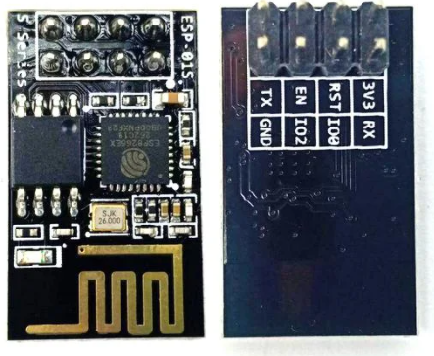

**Main Source :**

<https://sg.cytron.io/p-esp-01-wifi-serial-transceiver-module-esp8266>

**Pool Of Resource documents:**

<https://www.espressif.com/en/support/documents/technical-documents>

## Bellow are some of the Documents that are useful at first glance:

**ESP8266_Specifications_English.pdf :**

<https://www.elecrow.com/download/ESP8266_Specifications_English.pdf>

**DataSheet:**

This document introduces the specifications of ESP8266EX.

* [esp8266ex Datasheet](https://drive.google.com/file/d/1QzMuO3qgZkE5xNH9or70n64DD36k-4Vq/view?usp=sharing)
* Latest ver -> <https://www.espressif.com/sites/default/files/documentation/0a-esp8266ex_datasheet_en.pdf>

**AT instruction Set**

The AT Commands of the ESP8266 WiFi Module are **responsible for controlling all the operations of the module** like restart, connect to WiFi, change mode of operation and so forth.

[esp8266 AT instruction](https://drive.google.com/file/d/1zrOoTNiCZ-GEth75b6xNpIUiE0UkjG61/view?usp=sharing)

**AT Command Examples**

<https://drive.google.com/file/d/13Vv9Q8OBtUDhlzteNwt3D4QzYmw4ybpz/view>

**IEEE Frequency Standards:**

<https://en.wikipedia.org/wiki/IEEE_802.11#802.11n>

## 

## ESP8266 specification

#### **Features and specifications:**

* Model: ESP-01S
* Power: 3.3VDC, proper 3.3V voltage regulator and NO level shifter is needed as the IO pins are 5V tolerant.
* 802.11 b/g/n protocol
* Wi-Fi Direct (P2P), soft-AP
* Integrated TCP/IP protocol stack
* Integrated TR switch, balun, LNA, power amplifier and matching network
* Integrated PLLs, regulators, DCXO and power management units
* +19.5dBm output power in 802.11b mode
* Integrated temperature sensor
* Support antenna diversity
* Integrated low power 32-bit CPU could be used as an application processor
* Power down leakage current: < 10 uA
* I/O interfaces:
  + SDIO 1.1/2.0
  + SPI
  + UART
* Communication interfaces:
  + STBC
  + 1x1 MIMO
  + 2x1 MIMO
* A-MPDU & A-MSDU aggregation & 0.4 ms guard interval
* Wake up and transmit packets in < 2 ms
* Standby power consumption of < 1.0 mW (DTIM3)

# Ultrasonic Module - Ultrasonic Ranging Module (HC-SR04)

There are a lot of online sources mostly working with arduino but most resources should still be useful as reference for our project.

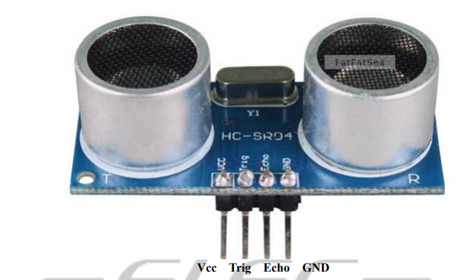

Product features: Ultrasonic ranging module HC - SR04 provides 2cm - 400cm non-contact measurement function, the ranging accuracy can reach to 3mm.

The modules include ultrasonic transmitters, receiver and control circuit. The basic principle of work:

1. Using IO trigger for at least 10us high level signal,
2. The Module automatically sends eight 40 kHz and detect whether there is a pulse signal back.
3. IF the signal back, through high level , time of high output IO duration is the time from sending ultrasonic to returning.
4. Test distance = (high level time×velocity of sound (340M/S) / 2,

## Bellow are some of the Documents that are useful at first glance:

DataSheet:

* [**https://datasheetspdf.com/pdf-file/1380136/ETC/HC-SR04/1**](https://datasheetspdf.com/pdf-file/1380136/ETC/HC-SR04/1)
* <https://cdn.sparkfun.com/datasheets/Sensors/Proximity/HCSR04.pdf>
* <https://www.electroschematics.com/wp-content/uploads/2013/07/HCSR04-datasheet-version-1.pdf>
* <https://www.electroschematics.com/wp-content/uploads/2013/07/HC-SR04-datasheet-version-2.pdf>

Pool of sources:

<https://datasheetspdf.com/datasheet/search.php?sWord=hc-sr04>

Tutorial:

<https://lastminuteengineers.com/arduino-sr04-ultrasonic-sensor-tutorial/>

Formula to cal distance:

<https://www.bananarobotics.com/shop/HC-SR04-Ultrasonic-Distance-Sensor>

<https://www.keyence.com/ss/products/sensor/sensorbasics/ultrasonic/info/>

## HC-SR04 specification

Features and Specification:

* Input Voltage: 5V
* Quiescent Current : <2mA
* Working Current: 15mA
* Current Draw: 20mA (Max)
* Digital Output: 5V
* Digital Output: 0V (Low)
* Working Temperature: -15°C to 70°C
* Sensing Angle: 30° Cone
* Angle of Effect: 15° Cone
* Ultrasonic Frequency: 40kHz
* Range: 2cm - 400cm
* Trigger Input Pulse width: 10uS TTL pulse
* Resolution : 0.3 cm
* Dimensions
  + Length: 43mm
  + Width: 20mm
  + Height (with transmitters): 15mm
  + Centre screw hole distance: 40mm x 15mm
  + Screw hole diameter: 1mm (M1)
  + Transmitter diameter: 8mm

# Infra-Red Module - TCRT5000

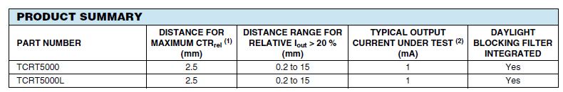

The TCRT5000 Sensor is used to detect color (Black and White scale) and distance. The sensor emits an infrared wave and then receives it. TCRT5000 Infrared Reflective Sensor Module is often used in line following robots and object sorting Robots since this module can sense if a surface is white or black.

The measuring distances range from 1mm to 8mm and the central point is about 2.5mm. There is also an onboard potentiometer to adjust the sensitivity.

This sensor has 4 pins:

* VCC: Module power supply – 5 V
* GND: Ground
* DOUT: Digital output data to the microcontroller
* AOUT: Analog output data to the microcontroller

You can see pinout of this module in the image below.

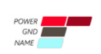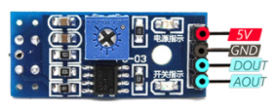

## Bellow are some of the Documents that are useful at first glance:

Pool of sources:

<https://www.vishay.com/product?docid=83760>

<https://www.vishay.com/optical-sensors/list/product-83760/>

<https://www.aerial.net/shop/product/161_196/1918/tcrt5000-reflectivepulse-sensor.html>

User Manual:

<https://www.gie.com.my/download/um/modules/sensor/um_line_tracking.pdf>

Tutorial:

<https://www.instructables.com/TCRT5000-Infrared-Reflective-Sensor-How-It-Works-a/>

## Infra-Red TCRT5000 specification

#### **Features:**

* Operating voltage: 3.3V or 5VDC
* 4-pin interface which are: AO, DO, GND and VCC:
  + AO is an analog output pin, the analog voltage will be high when there is no obstacle or infrared reflection. The voltage will gradually decrease when the infrared receive it high.
  + DO is a digital output pin from the sensor module, please connect to any digital input on your microcontroller. Will output logic LOW when object is detection
  + GND is where you connect to your controller ground or 0V
  + VCC is the +ve supply, connect to either +3.3V or +5V
* Two LED indicators:
  + Power indicator LED
  + Object detection indicator LED
* Obstacle detection range: 5mm to 10mm from the sensor
* Adjustable sensitivity with an onboard potentiometer, this translates to an adjustable detection range.
* Compact makes it easy to assembly
* Digital and analog output
* Compatible with all types of microcontrollers
* Dimension: 3.2cm x 1.4cm

#### 

# Motor Driver (L298N)

this **L298N Motor Driver Module** is a high power motor driver module for driving DC and Stepper Motors. This module consists of an L298 motor driver IC and a 78M05 5V regulator. **L298N Module** can control up to 4 DC motors, or 2 DC motors with directional and speed control.

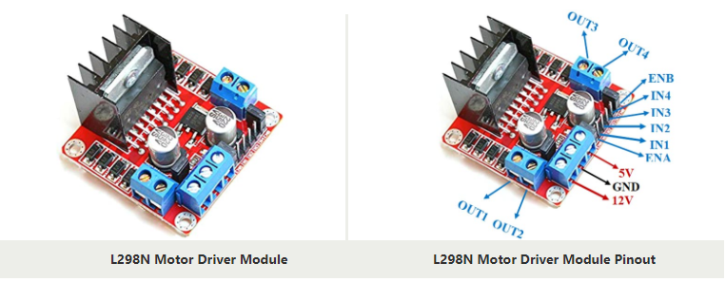

### **L298 Module Features & Specifications**

* Driver Model: L298N 2A
* Driver Chip: Double H Bridge L298N
* Motor Supply Voltage (Maximum): 46V
* Motor Supply Current (Maximum): 2A
* Logic Voltage: 5V
* Driver Voltage: 5-35V
* Driver Current:2A
* Logical Current:0-36mA
* Maximum Power (W): 25W
* Current Sense for each motor
* Heatsink for better performance
* Power-On LED indicator

## Bellow are some of the Documents that are useful at first glance:

User manual:

<https://asset.conrad.com/media10/add/160267/c1/-/en/001525437ML01/manual-1525437-iduino-st-1112-motor-controller-1-pcs.pdf>

Interface:

<https://lastminuteengineers.com/l298n-dc-stepper-driver-arduino-tutorial/>